Partnership Information Form 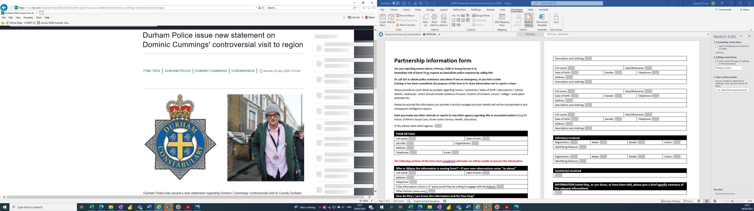

Remember to always call 999 if the crime is being committed now, the offender is nearby, or if you or a Person, Child or Young Person is at immediate risk of harm in danger.
Alternatively, you can call 101 and speak directly with a call handler or use our live chat service for general enquiries and advice as well as reporting non-urgent incidents or crimes. Please note the 101 Live chat service is not monitored 24/7. The purpose of this form is to share information NOT to report a crime.
This form should be used by partner agencies to share information with the police which has been gathered during the course of their work and may be of interest to law enforcement. It can be used to share information regarding potential criminal offences, conduct or behaviour, including, but not limited to; exploitation (sexual, criminal, labour etc.), serious and organised crime (including terrorism, drug supply, use of firearms etc.) and community tensions and issues. The information will be recorded on the Police Intelligence System and used to support activity by the police and, where appropriate, partner agencies.
The Information should be specific to a particular person, vehicle, or incident. i.e. one report per event and information relating to separate events should be on their own form. The submission of the information should be timely to the event.
Please provide as much detail as possible regarding names / nicknames / dates of birth / descriptions / vehicle details / addresses - which should include residence if known, location of incident, school / college / workplace attended etc.
Please be assured the information you provide is strictly managed and your details will not be incorporated in any subsequent intelligence reports.
Have you made any other referrals or reports to any other agency regarding this or associated matters? (e.g., Adult / Child’s Social Care, Youth Justice Service, Health, Education)
If YES, please state which agency:

Section 1: Your Details
Full name: |  |  | Date of birth:
Job title: |  | Organisation:
Address:
Telephone: | Email:

The following sections of the form must be completed otherwise we will be unable to process the information.
Section 2: The information is from my own observations enter:
Yes Go to Section 4
No Go to Section 3
Section 3
Full name: |  | Date of birth:
Address:
Telephone:
If the information is from a 3rd party would they be willing to engage with the Police?:
Other Partner (please state)?:
Section 4: Information Validation
The source of this information is
The information is
The information can be
Date you received the information:
ARE THEY AWARE THAT THIS INFORMATION IS BEING SHARED TO POLICE AND MAY BE ACTED UPON?
Section 5: Who is involved – (enter more as required) (Do not use initials / pseudonyms, make sure each nominal is clearly identifiable.
Full name: |  |  | Alias/Nickname:
Date of birth: | Gender: |  |  | Telephone numbers / WhatsApp/social media usernames etc:
Address:
Description and clothing:

Full name: |  | Alias/Nickname:
Date of birth: | Gender: |  | Telephone numbers / WhatsApp/social media usernames etc:
Address:
Description and clothing:

Full name: |  | Alias/Nickname:
Date of birth: | Gender: |  | Telephone numbers / WhatsApp/social media usernames etc:
Address:
Description and clothing:

Full name: |  |  | Alias/Nickname:
Date of birth: |  | Gender: |  |  | Telephone numbers / WhatsApp/social media usernames etc:
Address:
Description and clothing:
Vehicle(s) involved (Use Information Section for further vehicle information)
Registration: | Make: |  |  | Model: |  | Colour:
Identifying features:

Registration: | Make: | Model: | Colour:
Identifying features:

Location(s) involved (Provide specific addresses or identifiable locations)

Section 6: INFORMATION (what they, or you know, or have been told, please give a brief specific summary of the relevant information including any specific risks. Do not name the source of the information in this section)

Once complete please submit to force.intelligence@durham.police.uk

Please note our Force Intelligence Bureau is only manned between the hours of 07:30-16:30 Monday-Friday

